**ABSTRACT**

The System Development Life Cycle followed to develop the system has been listed in the following chapters :-

**Chapter 1 Project Profile**

This chapter gives a brief introduction of the project and the process followed in Inventory Management system..

**Chapter 2 Study Of Existing System and Requirement Specification**

The survey done and its finding are jotted in the second chapter. It explains about existing system and its functioning, problems in the existing system and different techniques used for gathering information are also given in this chapter.

**Chapter 3 Proposed Systems**

It proposes a new computerized system and defines the scope and objectives of Proposed System. Hardware and Software requirements for the new system and the Feasibility study findings are also specified in this chapter.

**Chapter 4 System Analysis**

This chapter includes analysis details like nomenclature used in the project. The Context Level Diagram and the Data Flow Diagrams, which show the flow of data from various files and departments, have been shown in the chapter. An Entity Relationship Diagram is also drawn to explain various relationships amongst entities. A Functional Decomposition Diagram is shown in this chapter which displays all the functions and modules included in the project.

**Chapter 5 System Design**

This chapter deals with the design phase details. Data Dictionary is prepared which lists all the fields from various tables. It includes all the design documents like Input/Output screens, table design, codes specification used while developing this system. The codes and their explanations are also given in this chapter. The menu design shows the hierarchy of all modules included in this project. Various programs have been written while developing this system. A program specification for each of these programs is also given in this chapter. The program specifications include input and output tables, and brief logic of the program. Layouts of various reports required by different users are also shown.

**Chapter 6 & 7 Testing and Implementation Plan**

This chapter includes the testing plan applied for testing the modules developed. After testing the system implementation phase was carried out.

**Chapter 8 User Manual**

The User Manual is given to the user for reference. It includes a brief introduction, Installation Guide, Getting Started and the Working of the System.

**TABLE OF CONTENTS**

**CHAPTER NO. TITLE**

1. **Synopsis**
2. **Project Profile**
3. **Study Of Existing System**

3.1 Study of Existing System

3.2 Problems with existing System

3.3 Client Requirement Specification

1. **Proposed System**

4.1 Scope of Proposed System

4.2 Objectives of Proposed System

4.3 Feasibility Study

4.4 H/W and S/W Requirement

4.5 System Work Flow

1. **System Analysis**

5.1 Context Level Diagram

5.2 Data Flow Diagram

5.3 Entity Relationship Diagram

1. **System Design**

6.1 Data Dictionary

6.2 Table Design

6.3 Form Design (with Input Values)

6.4 User Manual

**SYNOPSIS**

The Student dashboard is an online software solution to making an interactive platform between a University, It’s Staff and its Students.

The project is designed using HTML, CSS, JavaScript and php.

The website helps manage all events creating a news feed or a notice board for upcoming events along with equipping students with information related to their selected courses. It also provides an interface for students to send and receive messages to fellow students or faculty. Lastly, there is a forum page that helps students ask and answer questions.

These pages are all monitored by the university. Inappropriate messages or forum pages can be reported and will be dealt with by the concerned personnel.

To make sure no outsider is allowed access to this, Unique student ID’s are used during the registration process. When a student joins the University a unique ID is shared with him without which signing up to get access is not possible.

**PROJECT PROFILE**

There are four modules that are present within the Student Dashboard:

Student Information:

This is in regard to all student information such as his attendance, personal details and university related notices such as assignment, documentation submission, etc. .

Events & Notices:

All upcoming events that are affiliated with the university are posted here. These can be Sports selection days, College festival details, Campus placements, and other such events. Aside from this students can also access notices related to their college that could be in regard to placements or just college documentation that needs to be done.

Messages:

This system is designed so that people can send messages securely with one and other and staff without having to share personal details.

Forum:

Promotes independence and learning among students by letting them ask and answer questions or discussions.

**STUDY OF EXISTING SYSTEM**

Currently there is no such online system, students need to do things manually/ physically to get access to the information they need.

A general website for the university exists however information isn’t tailored to every students needs.

To get details on upcoming events and deadlines students need to visit the college office or look at notice boards to find the needed data which in many cases can be missed.

Aside from this all interaction with staff is done in person thus making it more time consuming.

**PROBLEMS WITH EXISTING SYSTEM**

* 1. Not all data is available online therefore Students and Teachers are required to be physically present to get the information they need.
  2. Important data can be over looked as there is no tailored system for each person
  3. Attendance records need to be maintained physically and there is no proper way for students to view them.
  4. No communication system has been created between fellow students or between students and teachers via the University. All interaction is done using personal contact details which can be abused.
  5. A platform to ask questions and answer them does not exist.

**CLIENT REQUIREMENT SPECIFICATION**

The client requires the following utilities in the automated system

* Ability to access data pertaining to the user remotely and without any errors
* Create a platform where in users can interact with each other without having to share personal contact details unrelated to the college
* Promote interaction and learning amongst users via a Student Community
* View their attendance regularly and be alerted when it does not meet certain criteria’s.
* View assignments that are due.
* Allow only registered college students / teachers / staff to register and use the website.

**SCOPE OF THE PROPOSED SYSTEM**

The student Dashboard aims to replace the manual labor needed by a student to stay updated with his college life by making all that information available online.

The System allows every user to login to a dashboard that is unique to him. The dashboard has data pertaining to his Personal details, Assignments and his attendance. Once logged in a user is allowed to communicate with each user on the system via messages. These messages require the user to know the senders User ID (Helps prevent spamming). The messages work more like an email system wherein users can log in to find all threads segregated subject wise and arranged from newest to oldest. The proposed system is designed to facilitate interactions amongst college students and teacher. To do so a student community is developed. This let’s all users post questions and answer them irrespective of their grade or class. Any user is allowed to view and reply to any or all threads posted. The last and a very important module of this system is its feed. This feed contains all the information on events and notices that a student should be informed of. This follows a similar sorting format of newer ones at the top and goes down to older ones. All event’s and news articles can only be published by college staff or teachers.

**OBJECTIVES OF PROPOSED SYSTEM**

The objective of the proposed system is to automate the manual system, for availing all the benefits of computerization. The proposed system will work according to the standards laid down by the existing system.

* Develop a user-friendly system.
* Provide accurate data.
* Remotely access data pertaining to ones course and college.
* Provide personal security.
* Allow communication between users
* Encourage students to hold healthy discussions.
* To provide authorized access to the system.

**NEED FOR COMPUTERIZATION**

The proposed system allows users to access accurate information remotely. It saves paper as well as reduces the manual work that needs to be done by printing documents and then posting them on notice boards. It provides a platform for users to communicate with each other while protecting their real world contact details.

By auto mating the whole process and making it online, it improves the outreach for information while making it easier to spread. This can be really time saving and makes it easier for one person to communicate with a larger group of people much more effectively.

##### REQUIRED SPECIFICATION

**SERVER CONFIGURATION**

Server : Quad Core i5 or Octa Core AMD Ryzen

RAM : 8 GB

HDD : 100 GB

Internet : 20 mbps

**CLIENT CONFIGURATION**

Client : Pentium IV

RAM : 512 MB

HDD : 40 GB

Others : Optical Mouse, Monitor,Keyboard.

Internet : 2 mbps

**SOFTWARE SPECIFICATION**

**Server Installation :** Windows 2000 Server

Sql Server 2000..

**Client Installation :** Windows XP

##### SOFTWARE USED FOR DEVELOPMENT

**Operating System :** Windows 10 Professional.

**Backend :** MYSQL / XAMPP

**Frontend :** PHP 8 / HTML 5 / CSS3/ JavaScript /Bootstrap

**NOMENCLATURE**

### Symbols used in DFD :

Following are the symbols used for drawing the Context Level Diagram and the Data Flow Diagrams.

* **Entity (Source or destination of Data)**
* **Process**
* **Data Store**
* **Repeated Entity**
* **Data Flow**

**CLASS LEVEL DIAGRAM**

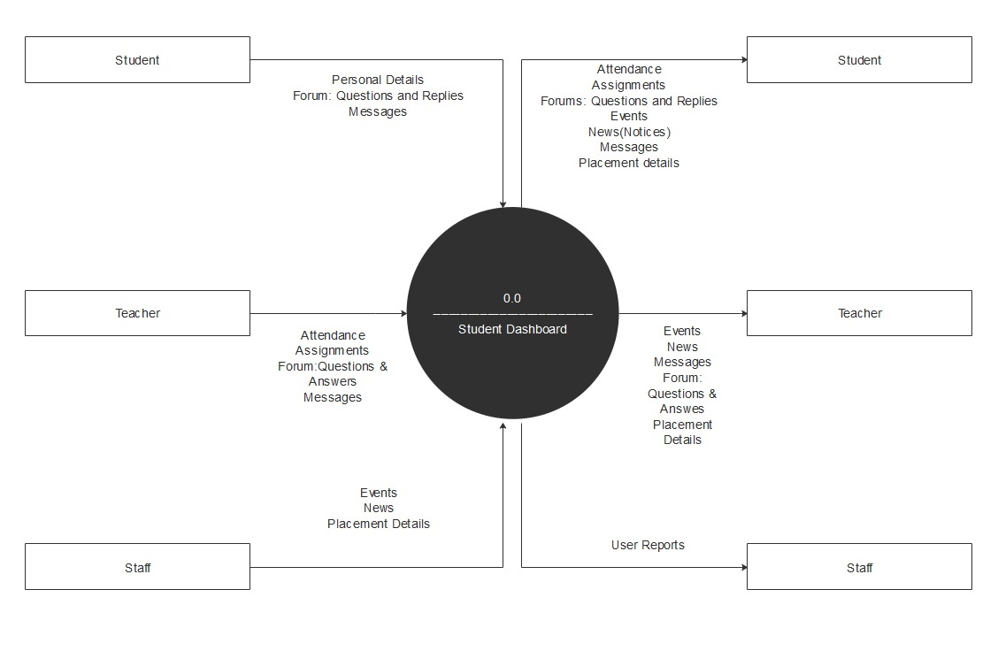

**DATA FLOW DIAGRAM**

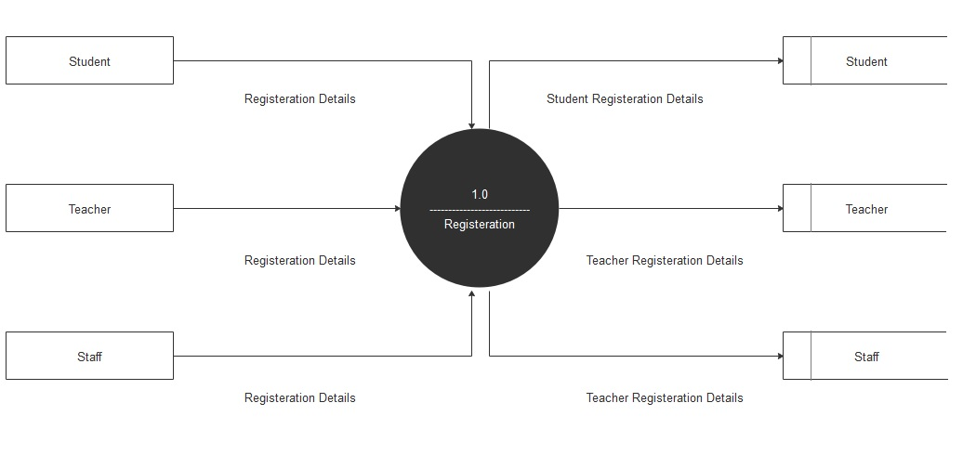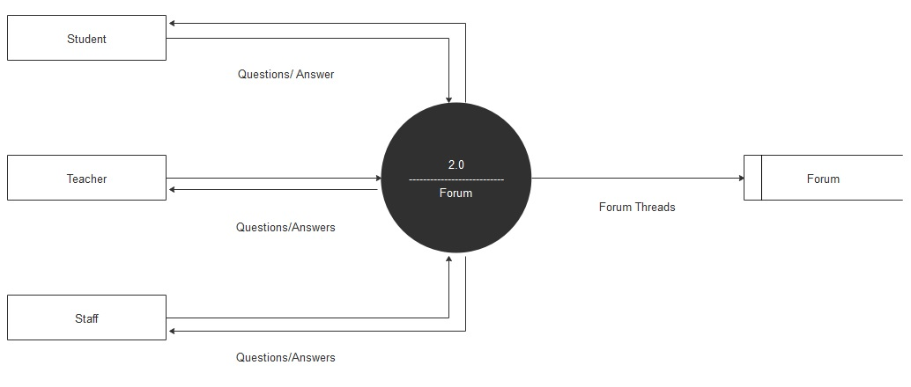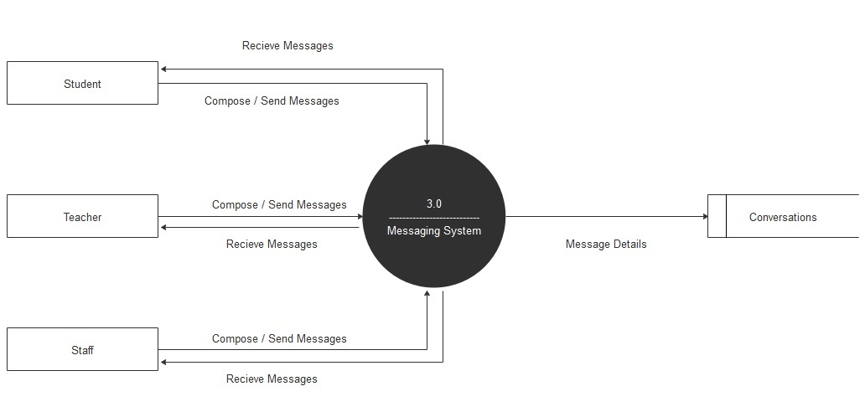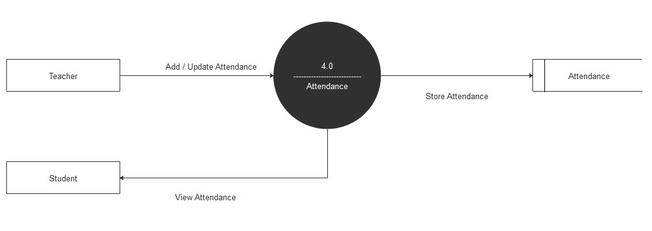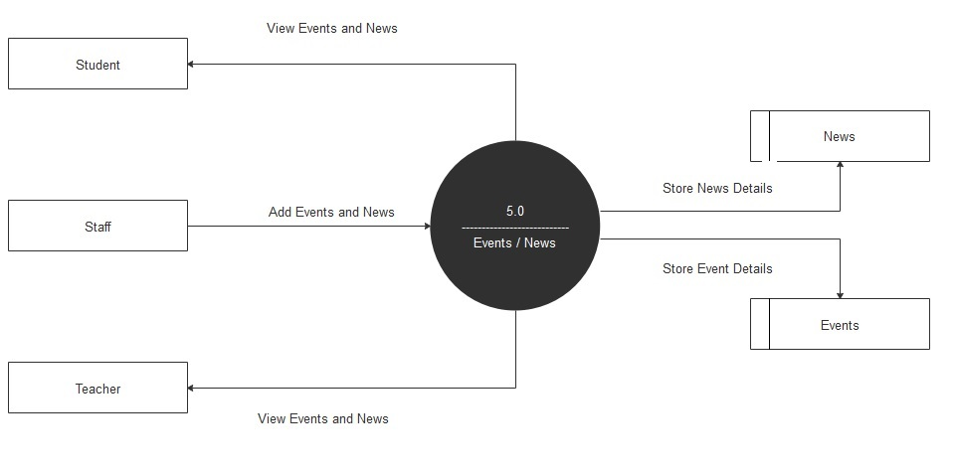

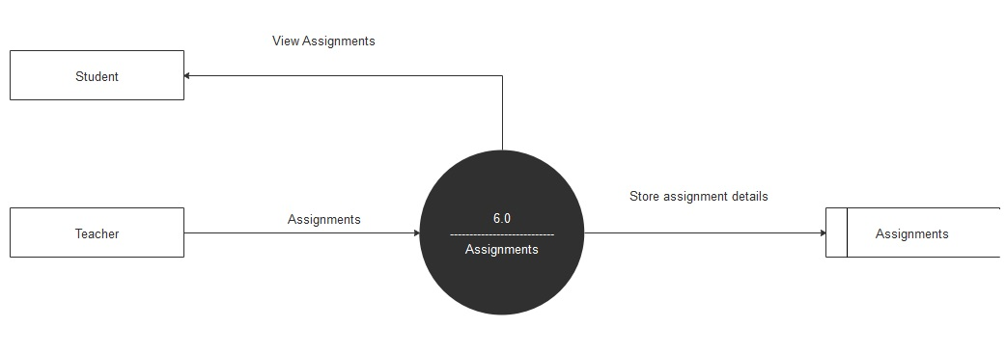

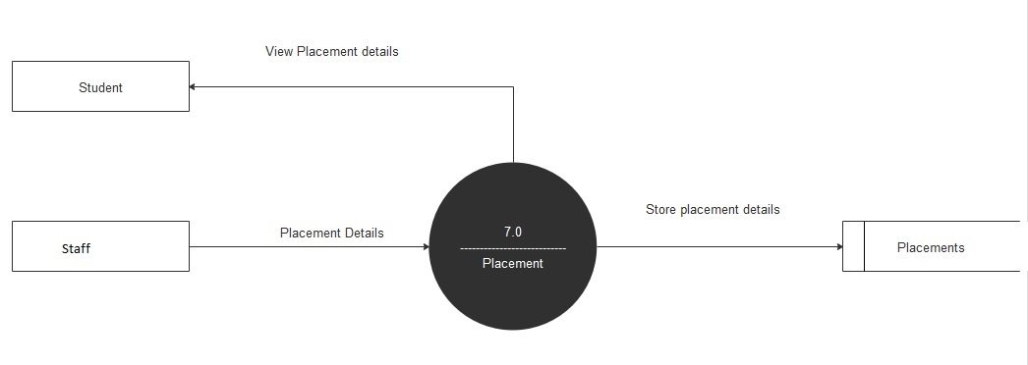

## DATA DICTIONARY

## Assignments

|  |  |  |  |  |  |  |
| --- | --- | --- | --- | --- | --- | --- |
| **Column** | **Type** | **Null** | **Default** | **Links to** | **Comments** | **MIME** |
| assignment_id (Primary) | int(8) | No |  |  |  |  |
| assignment_for | int(8) | No |  |  |  |  |
| assignment_title | varchar(64) | No |  |  |  |  |
| assignment_body | text | No |  |  |  |  |
| assignment_date | datetime | No |  |  |  |  |
| poster_id | int(8) | No |  |  |  |  |

### Indexes

| **Keyname** | **Type** | **Unique** | **Packed** | **Column** | **Cardinality** | **Collation** | **Null** | **Comment** |
| --- | --- | --- | --- | --- | --- | --- | --- | --- |
| PRIMARY | BTREE | Yes | No | assignment_id | 7 | A | No |  |

## bca

|  |  |  |  |  |  |  |
| --- | --- | --- | --- | --- | --- | --- |
| **Column** | **Type** | **Null** | **Default** | **Links to** | **Comments** | **MIME** |
| subject_id (Primary) | int(8) | No |  |  |  |  |
| subject_name | text | No |  |  |  |  |
| sem_no | int(8) | No |  |  |  |  |

### Indexes

| **Keyname** | **Type** | **Unique** | **Packed** | **Column** | **Cardinality** | **Collation** | **Null** | **Comment** |
| --- | --- | --- | --- | --- | --- | --- | --- | --- |
| PRIMARY | BTREE | Yes | No | subject_id | 6 | A | No |  |

## comments

|  |  |  |  |  |  |  |
| --- | --- | --- | --- | --- | --- | --- |
| **Column** | **Type** | **Null** | **Default** | **Links to** | **Comments** | **MIME** |
| comment_id (Primary) | int(8) | No |  |  |  |  |
| post_id | int(8) | No |  |  |  |  |
| comment_body | text | No |  |  |  |  |
| comment_user | int(8) | No |  |  |  |  |
| comment_date | datetime | No |  |  |  |  |

### Indexes

| **Keyname** | **Type** | **Unique** | **Packed** | **Column** | **Cardinality** | **Collation** | **Null** | **Comment** |
| --- | --- | --- | --- | --- | --- | --- | --- | --- |
| PRIMARY | BTREE | Yes | No | comment_id | 7 | A | No |  |

## conversations

|  |  |  |  |  |  |  |
| --- | --- | --- | --- | --- | --- | --- |
| **Column** | **Type** | **Null** | **Default** | **Links to** | **Comments** | **MIME** |
| conversation_id (Primary) | int(8) | No |  |  |  |  |
| conversation_subject | varchar(128) | No |  |  |  |  |

### Indexes

| **Keyname** | **Type** | **Unique** | **Packed** | **Column** | **Cardinality** | **Collation** | **Null** | **Comment** |
| --- | --- | --- | --- | --- | --- | --- | --- | --- |
| PRIMARY | BTREE | Yes | No | conversation_id | 8 | A | No |  |

## conversations_members

|  |  |  |  |  |  |  |
| --- | --- | --- | --- | --- | --- | --- |
| **Column** | **Type** | **Null** | **Default** | **Links to** | **Comments** | **MIME** |
| conversation_id | int(8) | No |  |  |  |  |
| user_id | int(8) | No |  |  |  |  |
| conversation_last_view | int(10) | No |  |  |  |  |
| conversation_deleted | int(1) | No |  |  |  |  |

### Indexes

| **Keyname** | **Type** | **Unique** | **Packed** | **Column** | **Cardinality** | **Collation** | **Null** | **Comment** |
| --- | --- | --- | --- | --- | --- | --- | --- | --- |
| unique | BTREE | Yes | No | conversation_id | 16 | A | No |  |
| user_id | 16 | A | No |

## conversations_messages

|  |  |  |  |  |  |  |
| --- | --- | --- | --- | --- | --- | --- |
| **Column** | **Type** | **Null** | **Default** | **Links to** | **Comments** | **MIME** |
| message_id (Primary) | int(10) | No |  |  |  |  |
| conversation_id | int(8) | No |  |  |  |  |
| user_id | int(8) | No |  |  |  |  |
| message_date | int(10) | No |  |  |  |  |
| message_text | text | No |  |  |  |  |

### Indexes

| **Keyname** | **Type** | **Unique** | **Packed** | **Column** | **Cardinality** | **Collation** | **Null** | **Comment** |
| --- | --- | --- | --- | --- | --- | --- | --- | --- |
| PRIMARY | BTREE | Yes | No | message_id | 18 | A | No |  |

## courses_subjects

|  |  |  |  |  |  |  |
| --- | --- | --- | --- | --- | --- | --- |
| **Column** | **Type** | **Null** | **Default** | **Links to** | **Comments** | **MIME** |
| subject_id (Primary) | int(8) | No |  |  |  |  |
| subject_name | text | No |  |  |  |  |
| course_name | text | No |  |  |  |  |
| sem_no | int(8) | No |  |  |  |  |

### Indexes

| **Keyname** | **Type** | **Unique** | **Packed** | **Column** | **Cardinality** | **Collation** | **Null** | **Comment** |
| --- | --- | --- | --- | --- | --- | --- | --- | --- |
| PRIMARY | BTREE | Yes | No | subject_id | 6 | A | No |  |

## events

|  |  |  |  |  |  |  |
| --- | --- | --- | --- | --- | --- | --- |
| **Column** | **Type** | **Null** | **Default** | **Links to** | **Comments** | **MIME** |
| event_id (Primary) | int(8) | No |  |  |  |  |
| event_title | varchar(32) | No |  |  |  |  |
| event_body | text | No |  |  |  |  |
| event_date | date | No |  |  |  |  |
| event_poster | int(11) | No |  |  |  |  |
| event_img | text | No |  |  |  |  |

### Indexes

| **Keyname** | **Type** | **Unique** | **Packed** | **Column** | **Cardinality** | **Collation** | **Null** | **Comment** |
| --- | --- | --- | --- | --- | --- | --- | --- | --- |
| PRIMARY | BTREE | Yes | No | event_id | 6 | A | No |  |

## news

|  |  |  |  |  |  |  |
| --- | --- | --- | --- | --- | --- | --- |
| **Column** | **Type** | **Null** | **Default** | **Links to** | **Comments** | **MIME** |
| news_id (Primary) | int(8) | No |  |  |  |  |
| news_title | varchar(32) | No |  |  |  |  |
| news_body | text | No |  |  |  |  |
| news_date | date | No |  |  |  |  |
| news_poster | int(8) | No |  |  |  |  |

### Indexes

| **Keyname** | **Type** | **Unique** | **Packed** | **Column** | **Cardinality** | **Collation** | **Null** | **Comment** |
| --- | --- | --- | --- | --- | --- | --- | --- | --- |
| PRIMARY | BTREE | Yes | No | news_id | 0 | A | No |  |

## posts

|  |  |  |  |  |  |  |
| --- | --- | --- | --- | --- | --- | --- |
| **Column** | **Type** | **Null** | **Default** | **Links to** | **Comments** | **MIME** |
| post_id (Primary) | int(8) | No |  |  |  |  |
| post_title | varchar(255) | No |  |  |  |  |
| post_body | text | No |  |  |  |  |
| post_user | int(8) | No |  |  |  |  |
| post_date | datetime | No |  |  |  |  |

### Indexes

| **Keyname** | **Type** | **Unique** | **Packed** | **Column** | **Cardinality** | **Collation** | **Null** | **Comment** |
| --- | --- | --- | --- | --- | --- | --- | --- | --- |
| PRIMARY | BTREE | Yes | No | post_id | 5 | A | No |  |

## sections

|  |  |  |  |  |  |  |
| --- | --- | --- | --- | --- | --- | --- |
| **Column** | **Type** | **Null** | **Default** | **Links to** | **Comments** | **MIME** |
| section_id (Primary) | int(8) | No |  |  |  |  |
| section_name | varchar(64) | No |  |  |  |  |

### Indexes

| **Keyname** | **Type** | **Unique** | **Packed** | **Column** | **Cardinality** | **Collation** | **Null** | **Comment** |
| --- | --- | --- | --- | --- | --- | --- | --- | --- |
| PRIMARY | BTREE | Yes | No | section_id | 3 | A | No |  |

## users

|  |  |  |  |  |  |  |
| --- | --- | --- | --- | --- | --- | --- |
| **Column** | **Type** | **Null** | **Default** | **Links to** | **Comments** | **MIME** |
| user_id (Primary) | int(8) | No |  |  |  |  |
| user_name | varchar(20) | No |  |  |  |  |
| user_password | varchar(40) | No |  |  |  |  |
| user_avatar | varchar(64) | No |  |  |  |  |
| user_full_name | varchar(32) | No |  |  |  |  |
| user_dob | date | No |  |  |  |  |
| user_gender | varchar(12) | No |  |  |  |  |
| user_address | varchar(64) | No |  |  |  |  |
| user_phone_number | bigint(10) | No |  |  |  |  |
| user_email | varchar(128) | No |  |  |  |  |
| emergency_name | varchar(32) | No |  |  |  |  |
| emergency_phone_number | bigint(10) | No |  |  |  |  |
| emergency_email | varchar(128) | No |  |  |  |  |
| emergency_address | varchar(64) | No |  |  |  |  |
| user_program | int(8) | No |  |  |  |  |
| user_sem | int(1) | No |  |  |  |  |
| user_college_id | int(8) | No |  |  |  |  |
| user_priority | int(1) | No |  |  |  |  |
| s1 | text | No |  |  |  |  |
| s2 | text | No |  |  |  |  |
| s3 | text | No |  |  |  |  |
| s4 | text | No |  |  |  |  |
| s5 | text | No |  |  |  |  |
| s6 | text | No |  |  |  |  |
| a1 | int(8) | No |  |  |  |  |
| a2 | int(8) | No |  |  |  |  |
| a3 | int(8) | No |  |  |  |  |
| a4 | int(8) | No |  |  |  |  |
| a5 | int(8) | No |  |  |  |  |
| a6 | int(8) | No |  |  |  |  |

### Indexes

| **Keyname** | **Type** | **Unique** | **Packed** | **Column** | **Cardinality** | **Collation** | **Null** | **Comment** |
| --- | --- | --- | --- | --- | --- | --- | --- | --- |
| PRIMARY | BTREE | Yes | No | user_id | 2 | A | No |  |

**User Manual**

All users need to first register using their unique college ID that is given to them on their fee receipt. Each ID can only make one account. Once their unique ID is verified, they must fill in all of their other personal details to get started. After the whole process of registration is complete users can View Assignments and Attendance, Send messages to other users, Join a discussion on the student community or view events and notices that they should be informed of.

**SCREENSHOTS**

